Step 1: At First Open Command Prompt in Administrator mode.

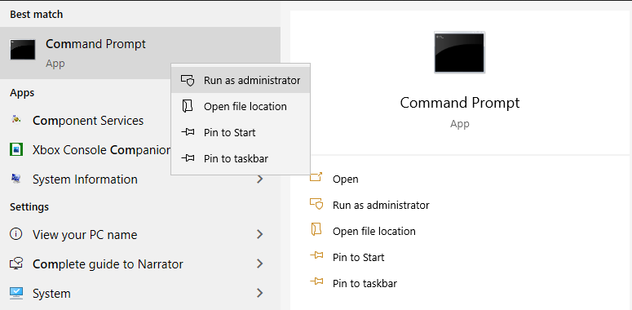

Step 2: Copy the Command line and past the Command Prompt

# cd "\Program Files\Common Files\microsoft shared\ClickToRun"

# OfficeC2rclient.exe /update user updatetoversion=16.0.13801.20266

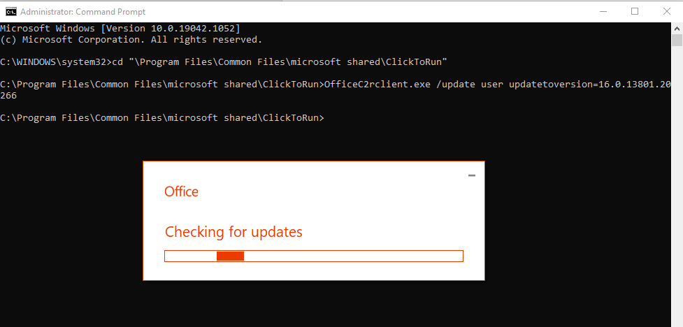

Wait Sometime (Finished Update)

***Step 3: Open Your Office Word (Blank Document) Click 🡪 File -> Account

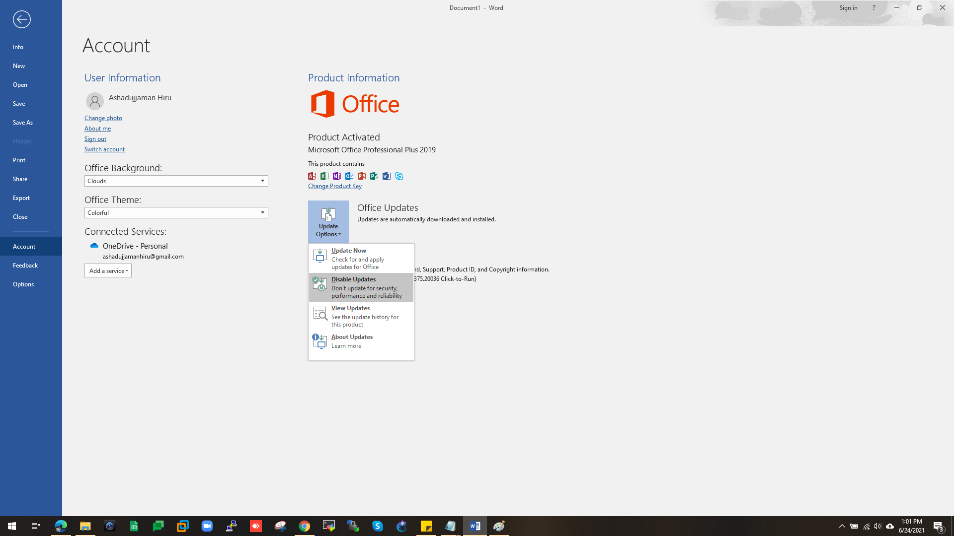

Step 4: File 🡪 Account 🡪 Office Updates (Click Disable Update)